# Get Started

# Register Tracker

Register tracking is used to track the details about the customer

Through phone verification, email verification, Two step

Authentication and identity verification.

# Phone verification

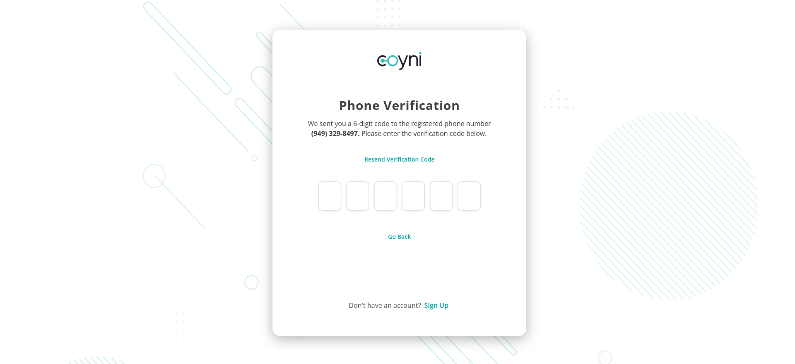

After entering the signin credentials it will land to phone verification

page. In that page we should enter verification code .Once the

verification succesfull it will takes to Two step authentication.

# Started Two Step Authentication

You’ve already verified your phone number and email during

account sign up,

which means your one step closer to harnessing the power of coyni.

After let’s go to Two-Step-Authentication.

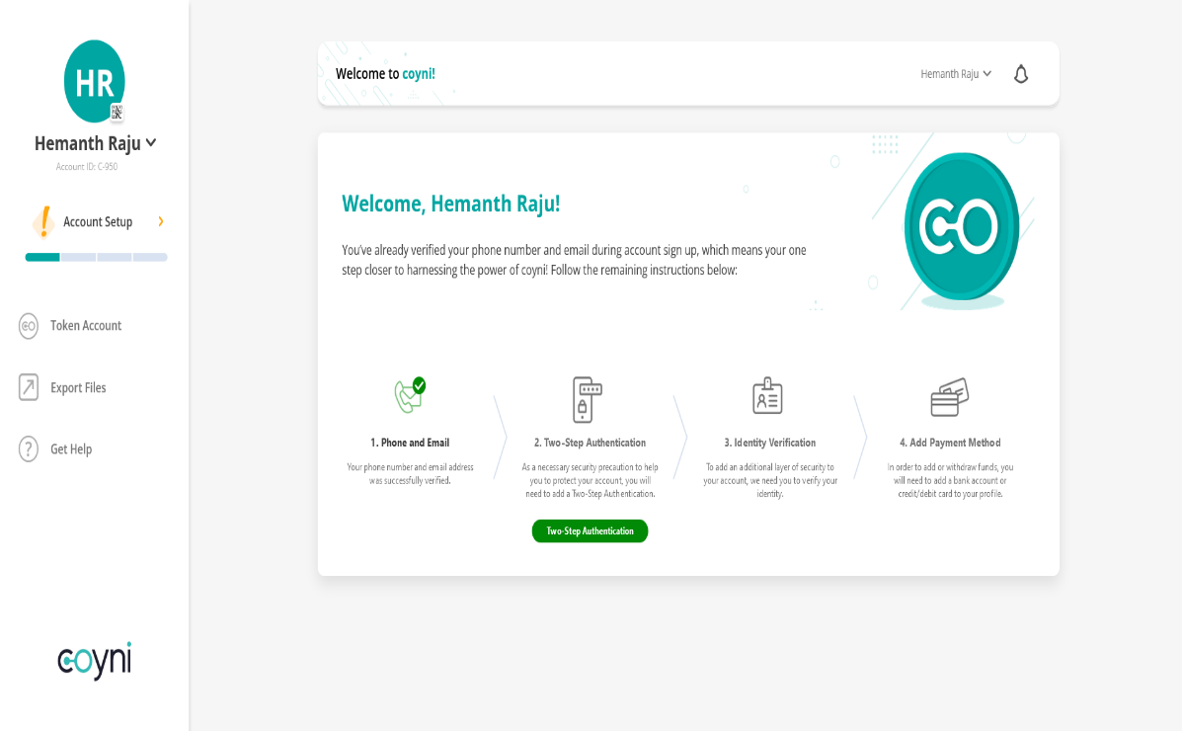

# Two Step Authentication

As a security measure, we require enabling Two-Step Authentication on your account. Simply open your  
compatible Two-Step Authentication mobile app and scan the QR Code below to get the verification code to  
activate this feature. Don’t have a Two-Step Authentication app?  **Click Here**

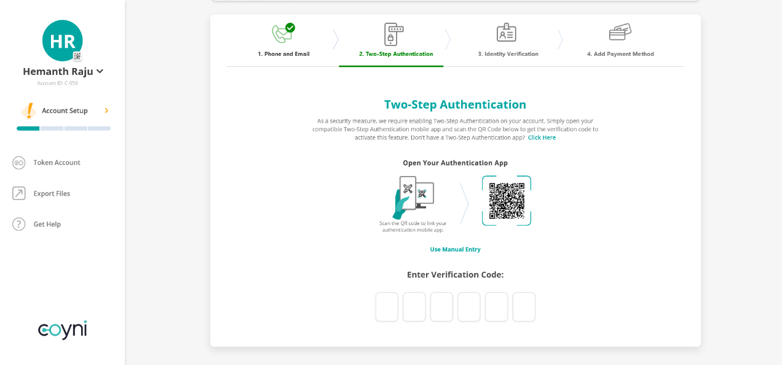

Two-Step Authentication was successfully activated, thank you.

The next step is to verify your identity by giving us a few personal details and a copy of your state-issued identification

# Identity Verfication

Please enter a valid mailing address of your primary residence along with a few of your personal details for identity verification. Please do not use a PO Box.

After uploading the documents and filled the required fields it will start verifying your details.

After verification your identification process will be completed

Your identity verification process completed successfully.

The next step is to adding the payment methods through banks , debit cards and credit cards.

# Add Payment Method

After Completion of Identity verification customer can add payment methods through Bank Account, Debit Card and Credit Card.

# Add Bank Account

By Click on the Bank Account method It will takes to add bank account page.

After giving the bank details it will landed to account verification page

After verification your bank account will be added succesfully



# Bank Account Added

Your bank account added successfully.

# Add Debit Card

Here we can do another payment method through Debit Card for that after click on Add payment method It will landed to Add New Payment methods page

Once we click on add new debit card method it will landed to Add New Debit Card page.

Once we given the card details . It will check the given card details are valid or not.

After authorization your debit card will be added to payment methods

# Add Credit Card

Here we can do another payment method through Credit Card for that after click on Add payment method It will land to add payment options page.There we select Add Credit Card.

Once we enter the credit card details It will verify card details

After pre-authorization process our credit card payment method will be added successfully in Add payment methods.

After completion of pre-authorization our credit card will be added successfully. We can see here

